A000-DR Congo-Songye-Kifwebe Statue-Kaaolin Painted Face-Early 20th c

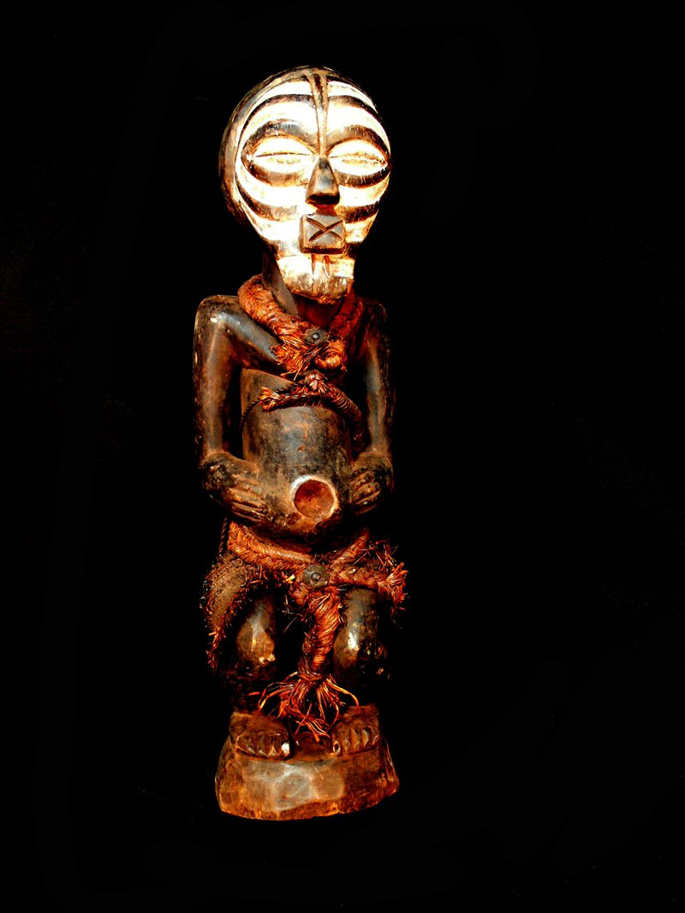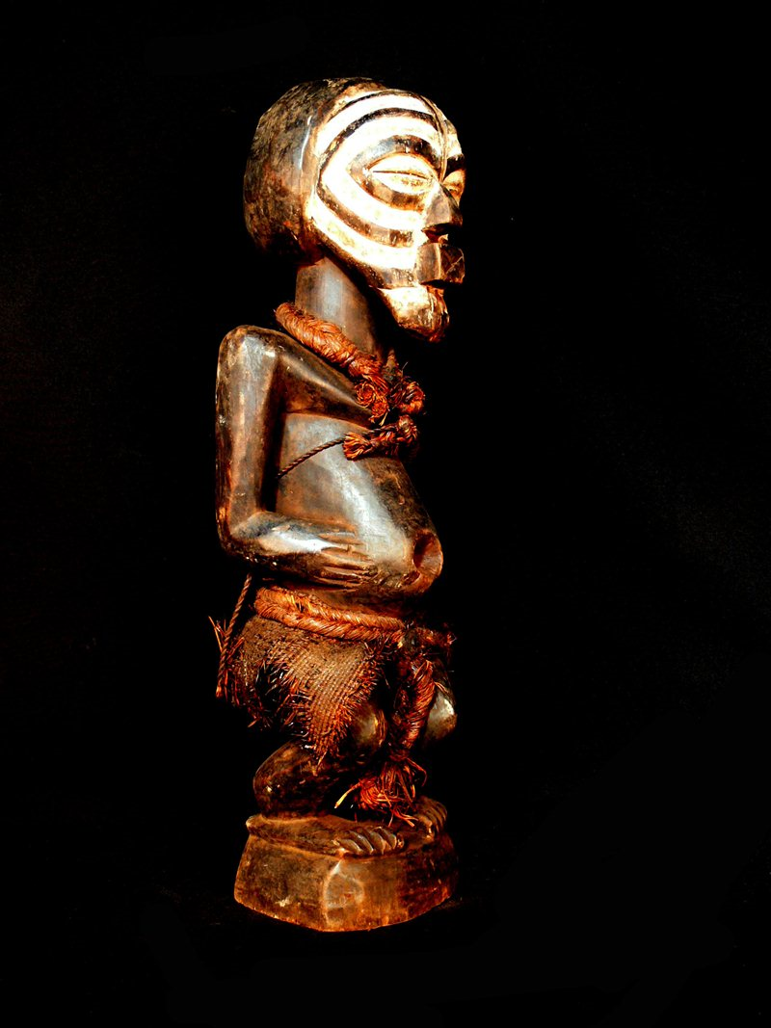

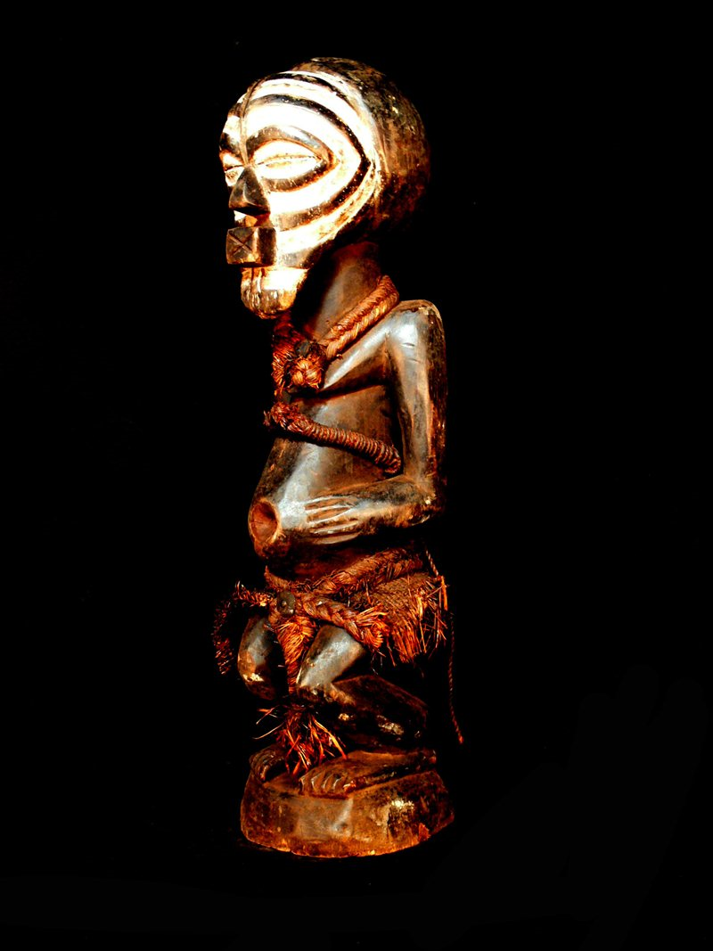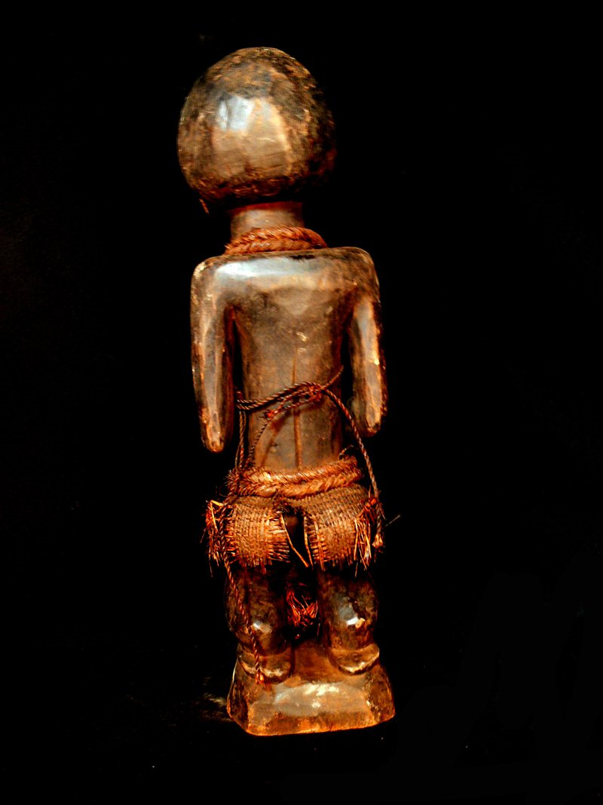

Figs. 1-4. DR Congo-Songye-Kifwebe Statue-early 20th c

Case No.: 6

**Accession No.**

**Formal Label:**

**Display Description:**

This Kifwebe statue has a kaolin painted face, is tied with raffia ropes and displays an everted navel. Ita patina attests to extensive ritual use.

**Accession Number:**

**LC Classification:**

**Date or Time Horizon:**

**Geographical Area:**

**Map:**

**GPS coordinates:**

**Cultural Affiliation:**

**Media: wood, pigments**

**Dimensions:** 3.86 pounds

**Weight:**

**Condition:**

**Provenance: Songye people,** D R Congo

**Discussion:**

**References:**